Bambu Labs A1 Combo
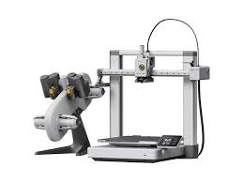
Specs:
- Build Volume
  - 256mm x 256mm x 256mm
  - 10.0787” x 10.0787” x 10.0787”
- Filament
  - Usable:
    - PLA (Probably what we’re using)
    - PETG
    - TPU
    - PVA
  - Usable but not recommended:
    - ABS
    - ASA
    - PC
    - PA
    - PET
    - Carbon Fiber Reinforced Polymer
- Holds up to 4 filament types and supports multi-color printing

